Industrial Internship Report on
“Data Science and Machine Learning”
Prepared by
[Archana G]

Executive Summary
This report provides details of the Industrial Internship provided by upskill Campus and The IoT Academy in collaboration with Industrial Partner UniConverge Technologies Pvt Ltd (UCT).

This internship was focused on a project/problem statement provided by UCT. We had to finish the project including the report in 6 weeks’ time.
My project was “Data Science and Machine Learning” Development.
This internship gave me a very good opportunity to get exposure to Industrial problems and design/implement solution for that. It was an overall great experience to have this internship.

TABLE OF CONTENTS

SL NO | CONTENT | PAGE NO
01 | Preface | 3
02 | Introduction | 4
2.1 | About UniConverege Technologices Pvt Ltd | 4
2.2 | About upskill Campus | 10
2.3 | Objectives | 12
2.4 | Reference | 13
2.5 | Glossary | 13
O3 | Problem Statements | 14
04 | Existing and Proposed solution | 15
05 | Performance | 17
5.1 | Test plan/ Test Cases | 17
5.3 | Test Procedure | 19
5.4 | Performance Outcome | 22
06 | My learnings | 24
07 | Future work scope | 25

Preface

The 6-week FULL STACK internship by Upskill Campus and UniConverge Technologies Pvt Ltd provides the structured online program for the beginners to an intermediate learners, emphasizing hands-on coding and the industry projects.

Program Objectives
It aims to build core Python skills for the software development, data analysis, and web apps, with daily tasks, live mentorship, and a final certificate valid for resumes.
Total duration matches student schedules, often winter/summer batches, accessible from Bengaluru via learn.upskillcampus.com.
Weekly Overview
Week 1: Frontend Fundamentals like, HTML, CSS, JAVASCRIPT (JS basics).
Week 2: Frontend: React, Angular basics, UI/UX principals.
Week 3: Backend Basics: Node.js and Express.js, RESTful APIs, Database concepts (MongoDB or PostgreSQL)
Week 4: Full stack Integration: Connecting frontend to backend, API integration and state management,
Authentication and authorization.
Week 5: Advance Topics: State management (Redux or Content API), Advanced backend concepts (middleware, caching), Deployment and hosting (Heroku, vercel, etc)
Week 6: Project Development: Build a full stack project, Practice and reinforce concepts, Prep for interviews or real-world projects.

Introduction

About UniConverge Technologies Pvt Ltd
A company established in 2013 and working in Digital Transformation domain and providing Industrial
solutions with prime focus on sustainability and RoI.
For developing its products and solutions it is leveraging various Cutting Edge Technologies e.g. Internet of
Things (IoT), Cyber Security, Cloud computing (AWS, Azure), Machine Learning, Communication
Technologies (4G/5G/LoRaWAN), Java Full Stack, Python, Front end etc.


- UCT IoT Platform ()

UCT Insight is an IOT platform designed for quick deployment of IOT applications on the same time providing valuable
“insight” for your process/business. It has been built in Java for backend and ReactJS for Front end. It has support for

MySQL and various NoSql Databases.
- It enables device connectivity via industry standard IoT protocols - MQTT, CoAP, HTTP, Modbus TCP, OPC UA
- It supports both cloud and on-premises deployments.

It has features to
• Build Your own dashboard
• Analytics and Reporting
• Alert and Notification
• Integration with third party application (Power BI, SAP, ERP)
• Rule Engine

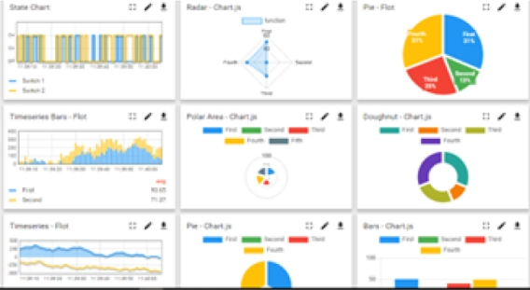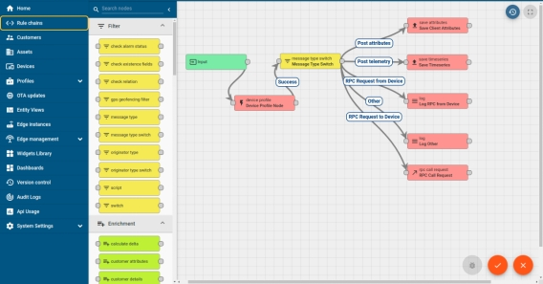


- Smart Factory Platform ()

Factory watch is a platform for smart factory needs.

It provides Users/ Factory
- with a scalable solution for their Production and asset monitoring
- OEE and predictive maintenance solution scaling up to digital twin for your assets.
- to unleased the true potential of the data that their machines are generating and helps to identify the KPIs and also improve them.
- A modular architecture that allows users to choose the service that they what to start and then can scale to more complex solutions as per their demands.
Its unique SaaS model helps users to save time, cost and money.
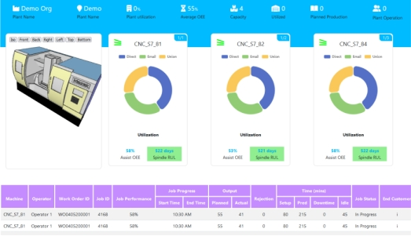


- Based Solution
UCT is one of the early adopters of LoRAWAN technology and providing solution in Agri tech, Smart cities, Industrial Monitoring, Smart Street Light, Smart Water/ Gas/ Electricity metering solutions etc.
- Predictive Maintenance
UCT is providing Industrial Machine health monitoring and Predictive maintenance solution leveraging Embedded system, Industrial IoT and Machine Learning Technologies by finding Remaining useful life time of various Machines used in production process.
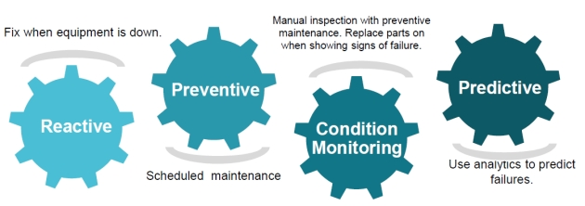

About upskill Campus (USC)

upskill Campus along with The IoT Academy and in association with Uniconverge technologies has facilitated the smooth execution of the complete internship process.
USC is a career development platform that delivers personalized executive coaching in a more affordable, scalable and measurable way.


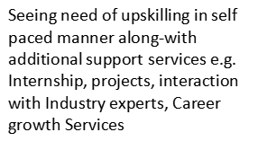
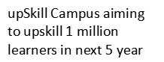



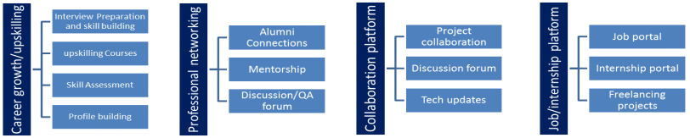

The IoT Academy

The IoT academy is EdTech Division of UCT that is running long executive certification programs in
collaboration with EICT Academy, IITK, IITR and IITG in multiple domains.

Objectives of this Internship program

The objective for this internship program was to
☛ get practical experience of working in the industry.
☛ to solve real world problems.
☛ to have improved job prospects.
☛ to have Improved understanding of our field and its applications.
☛ to have Personal growth like better communication and problem solving.

Reference
[1] IoT Academy
[2] upskill Campus (You tube Channel)
[3] Google

Glossary
Terms | Acronym
Basics | HTML, CSS, JAVASCRIPT Concepts.  Data Science and Machine Learning Concepts.
API | Application Programming Interface.  Set of rules for software interaction.
CRUD | Create, Read, Update, Delete.
DOM | Document Object Model.  HTML documents structure.  Machine Learning Models.
HTTP | Hypertext Transfer Protocol.  Data Transfer Protocol

Problem Statement

- Healthcare
Disease Prediction System
Build a machine learning model that predicts diseases such as diabetes or heart disease using patient health records.
Medical Image Classification
Develop a deep learning model to classify X-rays or MRI images for disease detection.

- Education
Student Performance Prediction
Predict student academic performance based on attendance, study hours, and previous scores.
Smart Attendance System
Create a face-recognition-based attendance system using computer vision.

- Business & Marketing
Customer Churn Prediction
Predict which customers are likely to stop using a company’s services.
Sales Forecasting System
Use historical sales data to forecast future product demand.
Recommendation System
Build a movie, product, or music recommendation engine similar to Netflix or Amazon.

Existing and Proposed solution
- WEATHER FORECASTING:

This Program for the basic Python learning ang here easily we can Know the Weather by giving some of the inputs. Like humidity, range of the wind.

- PASSWORD MANAGER:

In the project, we can know that security system and it can secure our password and credential details.

LIMITATIONS

- Weather Forecating: Existing apps like Weather.com, AccuWeather offer detailed forecasts are needed

the internet without internet it can’t be useable and technical problems are also occurs.

- Password Manager: Tools like FastAPI, VS Code are we need to install and it consists the internet to

download and install the tools to do the project without internet we can’t able to do the project.

SOLUTION
- Here, In the Weather Forecasting miniprojector there is no need of internet or need to download anything

in outside. We can just give the code into the SPYDER and gave input then we can get the output.

- Password Manager: As a major Project here easily we can store our Passwords and the credentials details

and we have to login and register the account to save the passwords.

Code submission (Github link):
https://github.com/archana-a11y/upSkills_project.git

Report submission (Github link):
https://github.com/archana-a11y/upskill_report.git

Performance Test

This is very important part and defines why this work is meant of Real industries, instead of being just academic project.
Here we need to first find the constraints.
How those constraints were taken care in your design?
What were test results around those constraints?
Constraints can be e.g. memory, MIPS (speed, operations per second), accuracy, durability, power consumption etc.
In case you could not test them, but still you should mention how identified constraints can impact your design,
and what are recommendations to handle them.

Test Plan/ Test Cases
- Weather Forecast App:

1Humidity: Test with valid/invalid city names.

2. Output: Verify temperature and description are displayed correctly.

- Password Manager:

1. Add Password: Test adding a password and verify it's stored encrypted.

2. Retrieve Password: Check if password is decrypted and shown correctly.

3. Delete Password: Verify password is removed from storage.

4. Security: Test encryption strength and handling of wrong credentials.

Test Procedure
- WEATHER FORECATING
def classify_weather(temperature, humidity, wind):
if temperature >30 and humidity >70:
return "hot and humidity"
elif temperature > 30 and humidity<= 70:
return "hot"
elif temperature <= 30 and humidity >60:
return "warm amd humid"
elif temperature <= 30:
return "pleasent"
elif temperature < 20 and wind =="strong":
return "cold and windy"
else:
return " cold"
print (" Weather Classification Expert System")
temp = float (input ("enter temperature (degree Celsius):"))
hum=float (input ("enter humidity (%):"))
wind=input ("enter wind condition (calm/strong):"). lower ()

weather=classify_weather (temp, hum, wind)
print ("\n weather condition:", weather)

- PASSWORD MANAGER

from flask import Flask, render_template, request, redirect, session
from pymongo import MongoClient
import bcrypt
import random
import string

app = Flask(__name__)
app.secret_key = "supersecretkey"

# MongoDB Connection
client = MongoClient("YOUR_MONGODB_CONNECTION_STRING")
db = client["password_manager"]
users = db["users"]
passwords = db["passwords"]

# Generate Strong Password
def generate_password(length=12):
characters = string.ascii_letters + string.digits + "!@#$%^&*"
return ''.join(random.choice(characters) for i in range(length))

# Home
@app.route("/")
def home():
return redirect("/login")

# Register
@app.route("/register", methods=["GET", "POST"])

def register():
if request.method == "POST":
username = request.form["username"]
password = request.form["password"]

hashed = bcrypt.hashpw(password.encode('utf-8'), bcrypt.gensalt())

users.insert_one({
"username": username,
"password": hashed
})

return redirect("/login")

return render_template("register.html")

# Login
@app.route("/login", methods=["GET", "POST"])
def login():
if request.method == "POST":
username = request.form["username"]
password = request.form["password"]

user = users.find_one({"username": username})

if user and bcrypt.checkpw(password.encode('utf-8'), user["password"]):
session["username"] = username
return redirect("/dashboard")

return render_template("login.html")

# Dashboard
@app.route("/dashboard", methods=["GET", "POST"])
def dashboard():
if "username" not in session:
return redirect("/login")

if request.method == "POST":
website = request.form["website"]

account = request.form["account"]
password = request.form["password"]

passwords.insert_one({
"username": session["username"],
"website": website,
"account": account,
"password": password
})

user_passwords = passwords.find({"username": session["username"]})
return render_template("dashboard.html", data=user_passwords)

# Generate Password
@app.route("/generate")
def generate():
if "username" not in session:
return redirect("/login")

pwd = generate_password()
return pwd

# Logout
@app.route("/logout")
def logout():
session.pop("username", None)
return redirect("/login")

if __name__ == "_main_":
app.run(debug=True)

Performance Outcome
- WEATHER FORECASTING
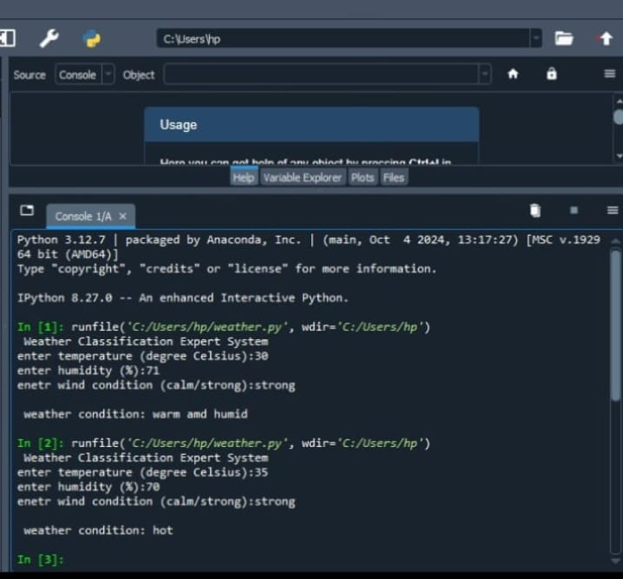

- PASSWORD MANAGER OUTPUT

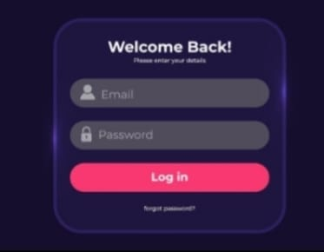

My learnings

During my Full stack internship, I gained hands-on experience Full stack Development means building both the frontend(client side) and backend (server) of a web application, along with the managing databases and deployment.
Key Learnings
Mastered writing clean, efficient code for automation scripts, data processing, and basic web applications using Flask or Django.
Developed problem-solving abilities through real-world projects, including algorithm implementation, error handling, and optimizing performance with techniques like memorization.
Explored web applications in AI/ML, databases (e.g., SQL integration, MongoDB), and version control with Git, bridging theory to practical use.
Career Impact These skills enhance my readiness for software engineering roles, enabling me to contribute immediately to backend development or data-focused tasks in internships at companies like Molex.
Building a portfolio from internship projects boosts my LinkedIn profile and interview performance, accelerating growth toward full-time AI/ML or Python developer positions.
Overall, this experience fosters logical thinking and collaboration, key for long-term career progression in tech.

Future work scope
1. Data‑pipeline enhancements: building robust ETL workflows with Python (pandas, Apache Airflow) to handle larger datasets.
2. Model deployment: packaging ML models into production‑ready APIs using Flask/FastAPI or Docker containers.
3. Performance tuning: optimizing Python code with Cython, multiprocessing, or JIT compilers (Numba) for speed.
4. Testing & CI/CD: implementing unit tests (pytest) and automated deployment pipelines for Python projects.
5. Advanced analytics: integrating Python with big‑data tools (PySpark) or visualization libraries (Plotly, Dash) for richer insights.
6. Security practices: adding authentication, encryption, and code‑review processes to Python applications.
7. Documentation: generating API docs with Sphinx or MkDocs for maintainable Python codebases.

